Guided Practice Report
Before completing this guided practice report, you should have completed the associated procedure.

Screenshots
After you have completed the procedure for the guided practice, add your screenshots below.
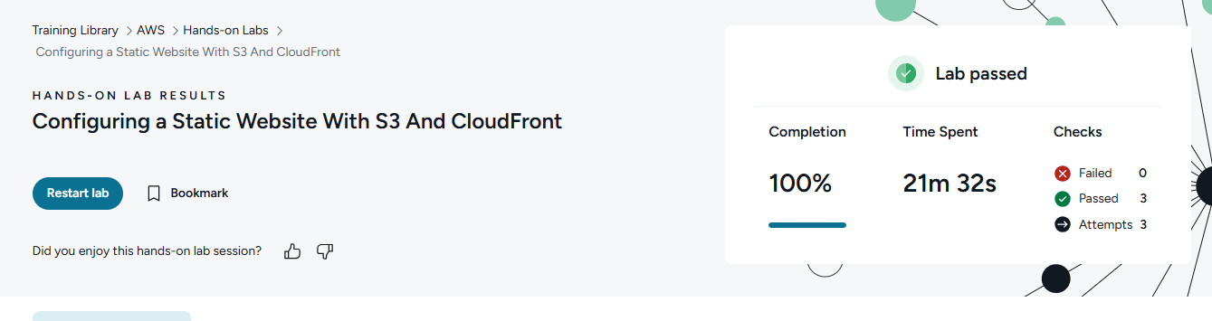

Reflection Questions
After you have completed the procedure for the guided practice, provide your answers to the reflection questions here.
What are the 4 types of characters you can use when naming an AWS S3 bucket?
S3 bucket names can use: lowercase letters, numbers, hyphens, and periods.

What kind of data can be stored in an AWS S3 bucket?
S3 buckets can store: files and data like images, videos, documents, backups, logs, and website files.

Why might you choose to uncheck the Block all public access option when you create an AWS S3 bucket?
Uncheck “Block all public access” when: you want the bucket’s files to be public, like for a static website.

What is an AWS S3 bucket website endpoint?
S3 bucket website endpoint: the public URL people use to visit a static website hosted in the bucket.

